Create a simple cloud software application for Car Booking Reservation System using any Cloud Service Provider to demonstrate SaaS.
AIM
To design and develop a Car Booking Reservation System using Zoho Creator as a cloud service provider and demonstrate the Software as a Service (SaaS) model, where users can book cars through a web-based application.
PROCEDURE
- Login to Zoho Creator using a valid Zoho account.
- Click on Create Application and select Create from Scratch.
- Enter the application name as Car Booking Reservation System.
- Create a form named Car Booking Form.
- Add the following fields in the form:
  - Customer Name
  - Gender
  - Mobile Number
  - Email ID
  - Car Type (Hatchback / Sedan / SUV)
  - Car Model
  - Booking Type (Local / Outstation)
  - Pickup Location
  - Drop Location
  - Pickup Date
  - Return Date
  - Payment Mode
  - Total Fare
- Save the form and arrange the fields properly.
- Configure access permissions for users to submit booking details.
- Publish the application to the cloud using Zoho Creator.
- Test the application by entering sample booking details.
- Verify that the data is stored and accessible online.
Output
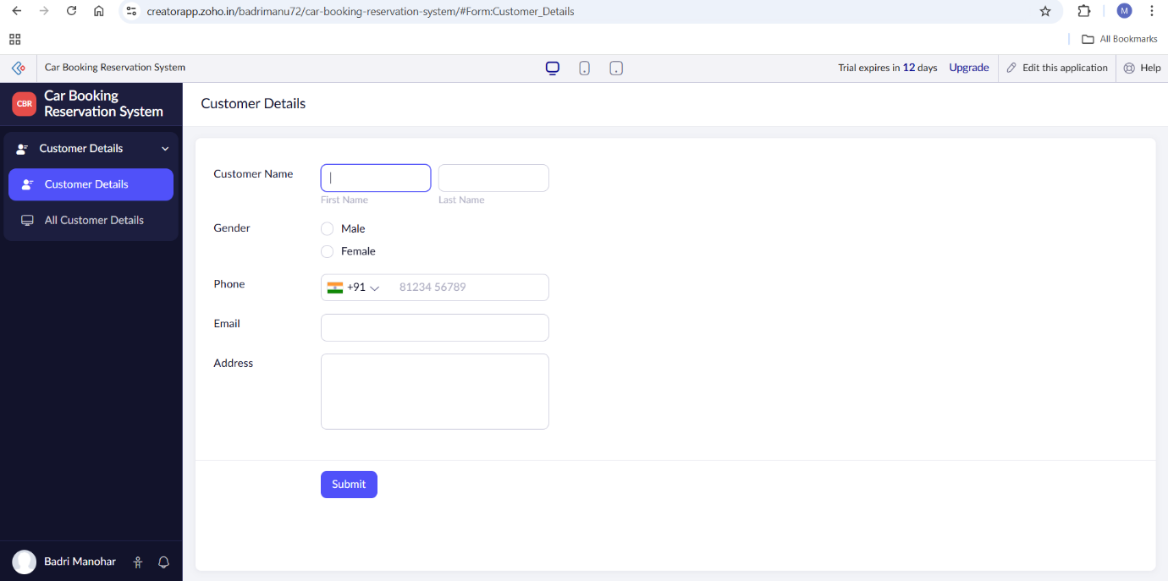
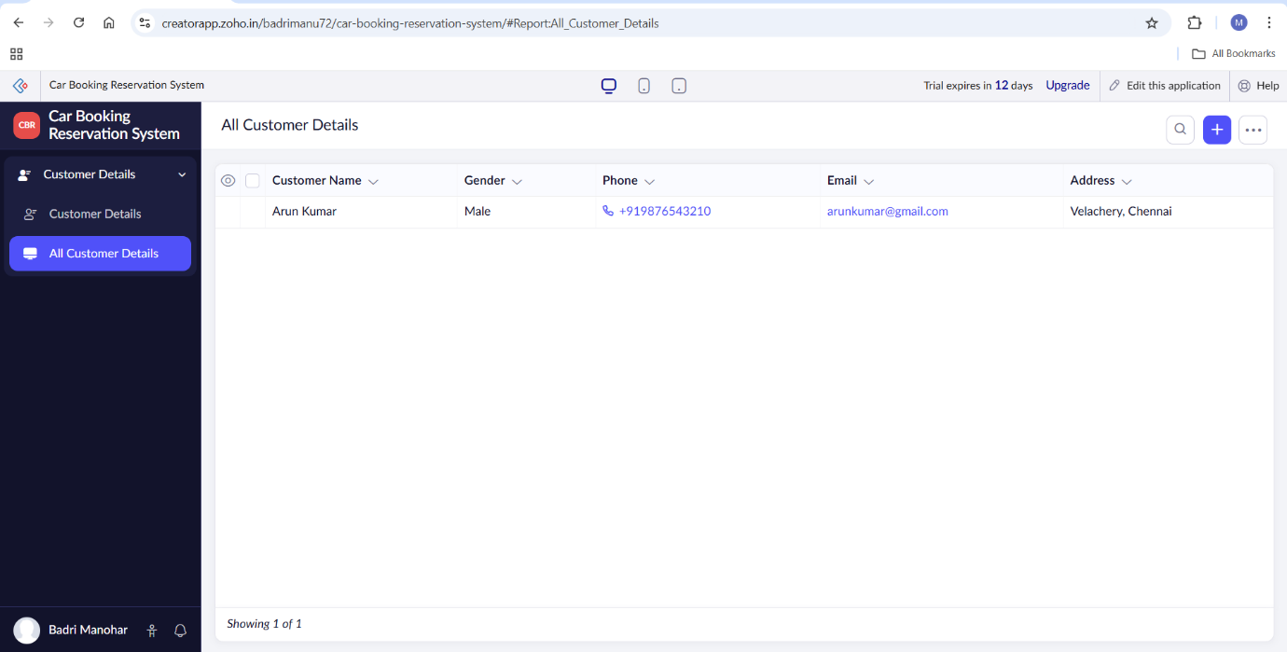
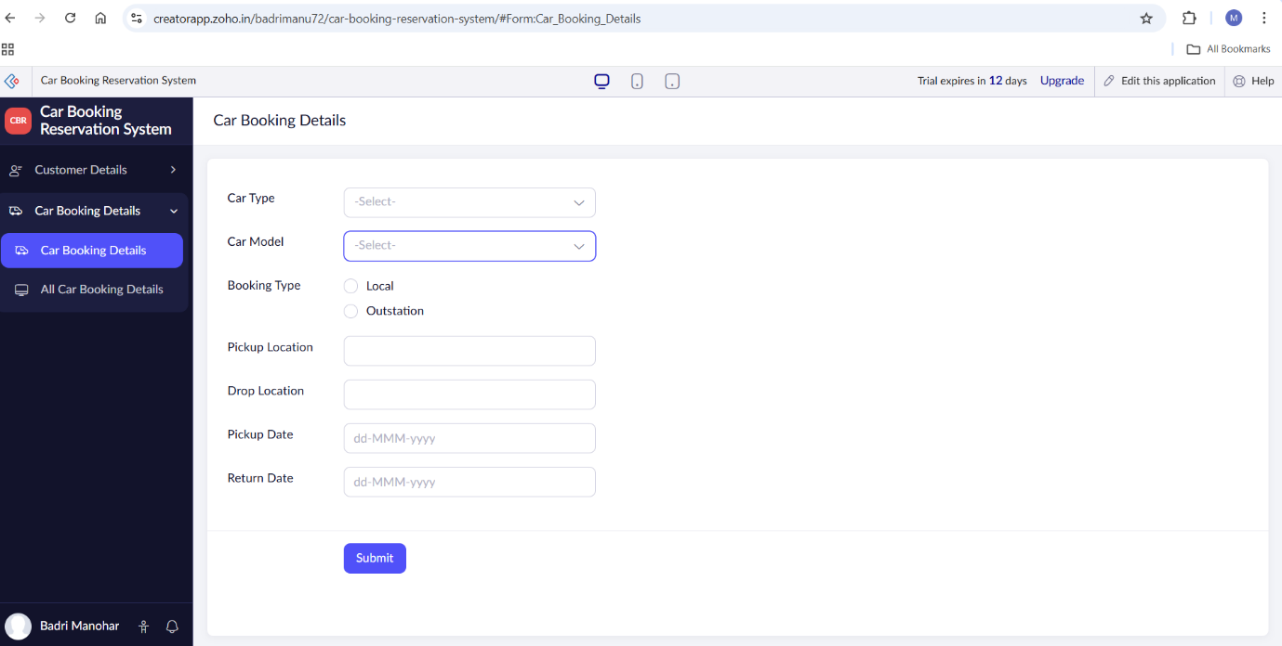
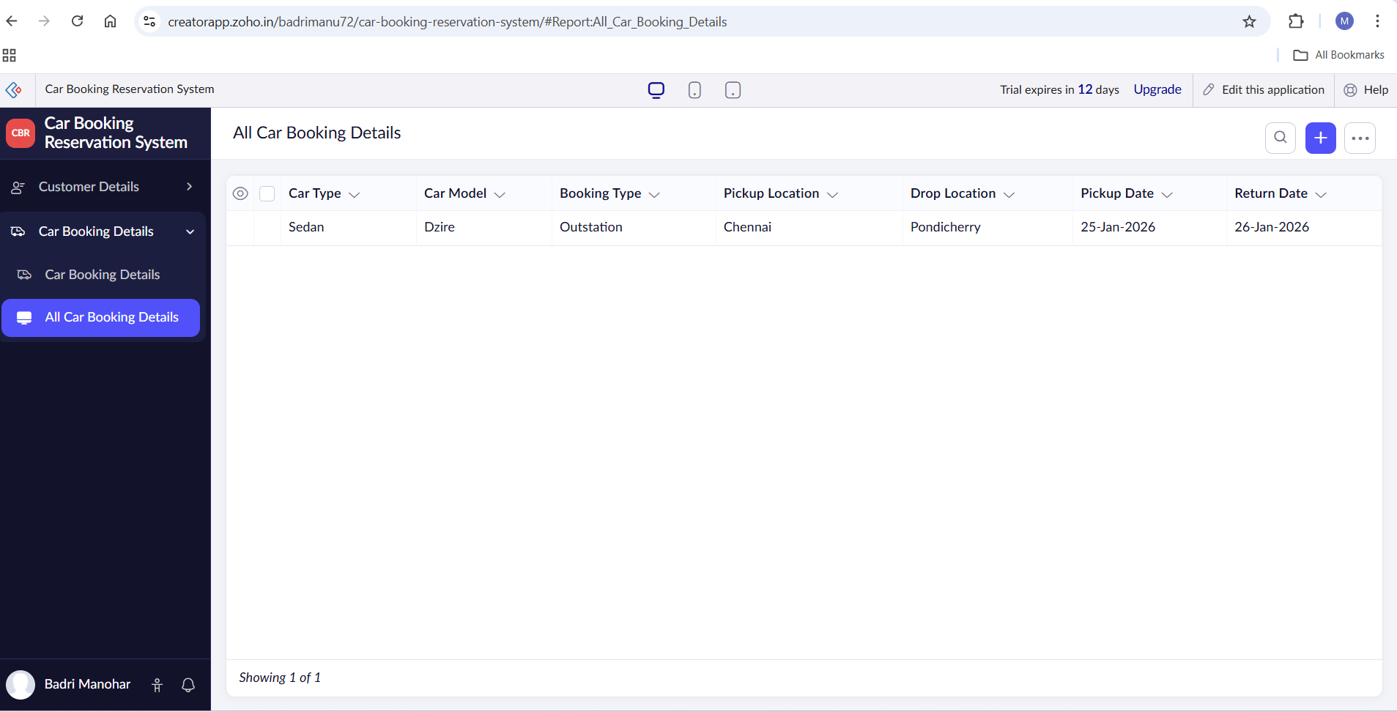
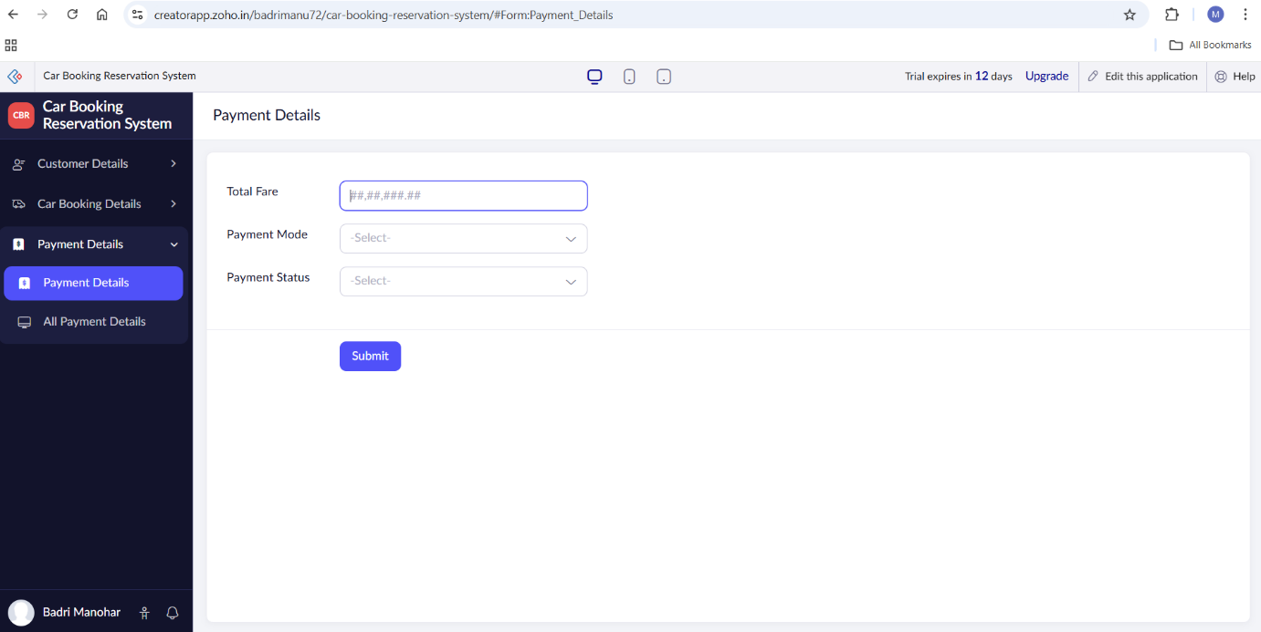
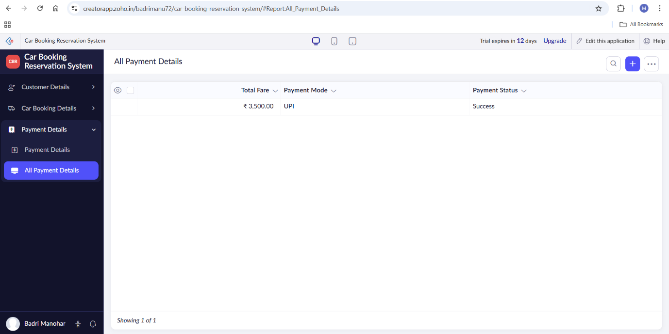

Result
A Car Booking Reservation System was successfully created and deployed using Zoho Creator as a Software as a Service (SaaS) application. The system allows users to book cars, enter journey details, and make payments online. The application can be accessed anytime and anywhere through a web browser without installing any software, thereby demonstrating the SaaS model.

